WATER QUALITY MONITORING SYSTEM

**A PROJECT REPORT**

*Submitted by*

**MEDAGAM V S MANJUNADHA REDDY [RA2211031010117]**

**BHARATH R [RA2211056010016]**

**MUKUNDAN S [RA2211056010033]**

**NIKITA KUMARASAMY [RA2211003010418]**

**ADITYA SINHA [RA2211003010449]**

**BHARAT MALHOTRA [RA2211003010461]**

*Under the Guidance of*

## **Dr. TYJ NAGA MALLESWARI**

Associate Professor, Department of Networking and Communications

&

## **Dr. S. USHASUKHANYA**

Assistant Professor, Department of Networking and Communications

*In partial fulfillment of the Requirements for the Degree of*

**BACHELOR OF TECHNOLOGY**

**in**

**COMPUTER SCIENCE AND ENGINEERING**

**&**

**CSE WITH SPECIATIZATION IN DATA SCIENCE & IT**



**DEPARTMENT OF NETWORKING AND COMMUNICATIONS SCHOOL OF COMPUTING**

**COLLEGE OF ENGINEERING AND TECHNOLOGY SRM INSTITUTE OF SCIENCE AND TECHNOLOGY KATTANKULATHUR -603203**

**MAY 2024**

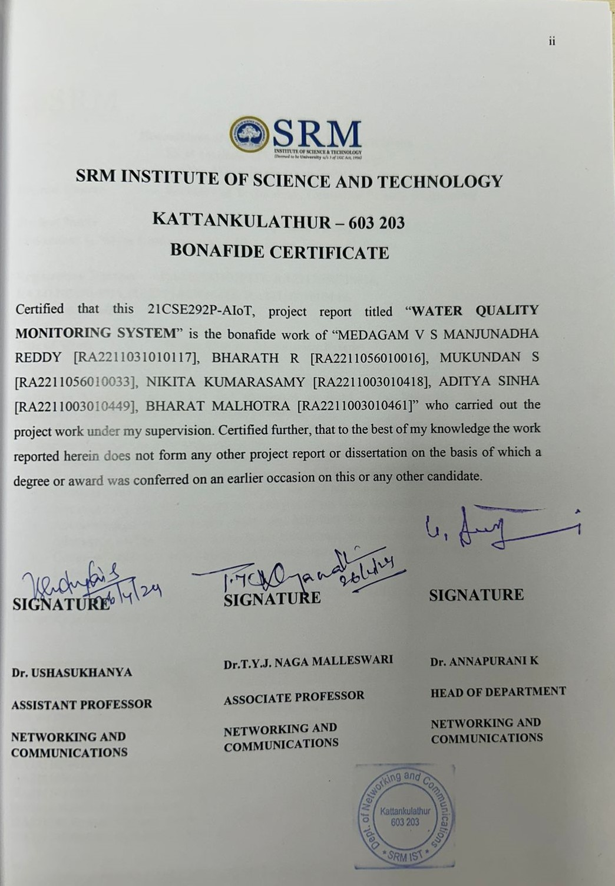

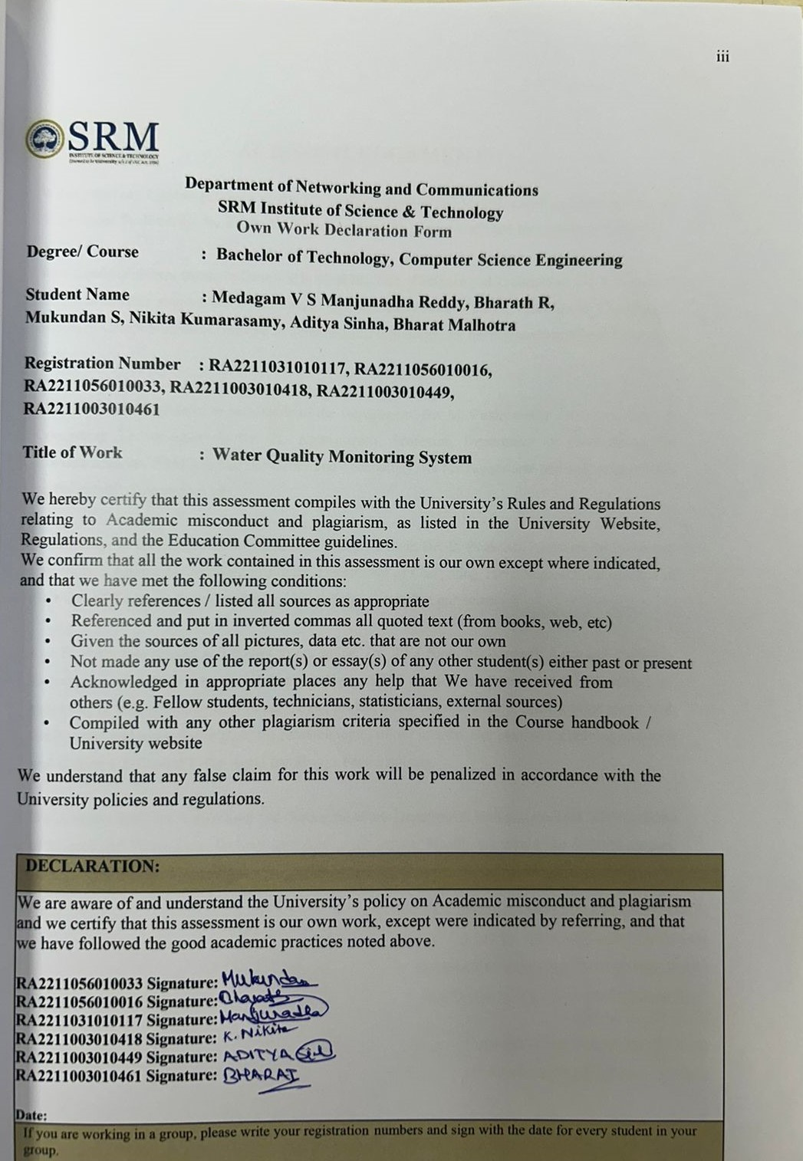

**ACKNOWLEDGEMENT**

We express our humble gratitude to **Dr. C. Muthamizhchelvan**, Vice-Chancellor, SRM Institute of Science and Technology, for the facilities extended for the project work and his continued support.

We extend our sincere thanks to Dean-CET, SRM Institute of Science and Technology, **Dr. T.V. Gopal**, for his invaluable support.We wish to thank **Dr. Revathi Venkataraman**, Professor & Chairperson, School of Computing, SRM Institute of Science and Technology, for her support throughout the project work.

We are incredibly grateful to our Heads of the Department, **Dr. M. Pushpalatha** Professor**,** Dept. of Computing Technologies & **Dr. K. Annapurani**, Professor,Department of Networking and Communications, SRM Institute of Science and Technology, for her suggestions and encouragement at all the stages of the project work.

We register our immeasurable thanks to our Faculty Advisor**, Dr. B. Prakash**, Assistant Professor and **Dr. Suresh Anand M,** Assistant Professor, Department of Computing Technologies, SRM Institute of Science and Technology, for leading and helping us to complete our course.

Our inexpressible respect and thanks to our guide, **Dr. TYJ Naga Malleswari**, Associate Professor, Department of Networking and Communications, SRM Institute of Science and Technology, for providing us with an opportunity to pursue our project under her mentorship. She provided me/us with the freedom and support to explore the research topics of our interest. Her passion for solving problems and making a difference in the world has always been inspiring.

We sincerely thank the Networking and Communications Department, staff and students, SRM Institute of Science and Technology, for their help during our project. Finally, we would like to thank parents, family members, and friends for their unconditional love, constant support, and encouragement.

NIKITA KUMARASAMY [RA2211003010418]

ADITYA SINHA [RA2211003010449]

BHARAT MALHOTRA [RA2211003010461]

MEDAGAM V S MANJUNADHA REDDY [RA2211031010117]

BHARATH R [RA2211056010016]

MUKUNDAN S [RA2211056010033]

# ABSTRACT

Water quality monitoring systems play a critical role in safeguarding human health and environmental sustainability by assessing and maintaining the quality of water resources. This abstract provides an overview of such systems, highlighting their importance, components, methods, and applications. Water quality monitoring involves the systematic measurement and analysis of physical, chemical, and biological parameters to evaluate the suitability of water for various uses. Key parameters commonly monitored include temperature, pH, dissolved oxygen, turbidity, conductivity, and concentrations of pollutants such as nutrients, heavy metals, and pathogens. Monitoring can be conducted using a combination of in-situ sensors, remote sensing technologies, and laboratory analysis. In-situ sensors are deployed directly in water bodies to provide real-time data, while remote sensing techniques utilize satellites or aerial platforms to assess water quality over larger spatial scales. Laboratory analysis offers high precision and accuracy for certain parameters but may require time-consuming sample collection and processing. Water quality monitoring systems are utilized in a wide range of applications, including drinking water management, wastewater treatment, agricultural runoff monitoring, aquatic ecosystem assessment, and industrial process control. These systems aid in detecting pollution, tracking environmental trends, assessing compliance with regulatory standards, and guiding decision-making processes for water resource management and conservation efforts. Continuous advancements in sensor technology, data analytics, and remote monitoring capabilities are enhancing the effectiveness and efficiency of water quality monitoring systems, enabling stakeholders to address emerging challenges such as climate change impacts, population growth, and emerging contaminants. Overall, water quality monitoring systems are indispensable tools for ensuring the sustainability and resilience of water resources in the face of growing environmental pressures and human activities.

**TABLE OF CONTENTS**

**Chapter TITLE Page No.**

|  |  |
| --- | --- |
| **Abstract**  **List of Figures**  **List of Abbreviations** | v  vii  viii |
| **1. INTRODUCTION** | **1** |
| 1.1 Understanding Water Quality Monitoring | 1 |
| 1.2 Components of a Water Quality Monitoring System | 2 |
| **2. LITERATURE REVIEW** | **4** |
| 2.1 Advances in Sensor Technologies | 4 |
| 2.2 Integration of Emerging Technologies | 4 |
| **3.** **SYSTEM ARCHITECTURE AND DESIGN** | **8** |
| 3.1 Components | 9 |
| 3.2 System Architecture | 9 |
| 3.3 Design considerations | 10 |

# METHODOLOGY 11

# CODING AND TESTING 13

# RESULTS 22

# CONCLUSION AND FUTURE SCOPE 24

# REFERENCES 26

**List of Figures**

# Fig.No TITLE PAGE NO

|  |  |  |
| --- | --- | --- |
| 3.1 | System Architecture Diagram | 8 |
| 3.2 | System Architecture Flowchart | 9 |
| 4.1 | Hardware Prototype | 12 |
| 5.1 | Pre-Processing Data Graph | 18 |
| 5.2 | Box Plot | 19 |
| 5.3 | Pair Plot | 20 |
| 5.4 | Heatmap | 21 |
| 6.1 | Plot Comparison O2 and Temperature | 22 |
| 6.2 | Plot Comparison pH and Conductivity | 23 |
|  |  |  |

**LIST OF ABBREVATIONS**

**BOD** Biochemical Oxygen Demand

**COD** Chemical Oxygen Demand

**UAV** Unmanned Aerial Vehicles

**IoT** Internet of Things

**WSN** Wireless Sensor Networks

**IoS** Internet of Services

**IoE** Internet of Energy

**MQTT** Message Queuing Telemetry Transport

**CHAPTER 1**

**INTRODUCTION**

**1.1 Understanding Water Quality Monitoring**

Water quality monitoring stands as a critical pillar in safeguarding the health and sustainability of our planet's most precious resource: water. It encompasses a multifaceted approach, integrating systematic observation and analysis of various parameters to assess the condition of water bodies accurately. By evaluating the physical, chemical, and biological aspects of water, this practice provides invaluable insights into the health and safety of aquatic environments, essential for sustaining life and ecosystems. Through continuous monitoring efforts, scientists and environmentalists can detect and track changes in water quality over time. This proactive approach enables the identification of potential threats such as pollution, contamination, and habitat degradation, allowing for timely interventions to mitigate risks. By leveraging advanced technologies and standardized methodologies, water quality monitoring systems ensure the collection of reliable and consistent data, facilitating informed decision-making processes. The data-driven nature of water quality monitoring empowers stakeholders to make evidence-based decisions aimed at protecting human health and preserving aquatic ecosystems. By analyzing trends and patterns in water quality parameters, authorities can develop targeted strategies to address specific challenges and manage resources effectively. Furthermore, by fostering collaboration between various stakeholders, including government agencies, research institutions, and local communities, water quality monitoring initiatives promote collective action towards achieving sustainable water management goals .Water quality monitoring also plays a vital role in enhancing public awareness and engagement regarding water-related issues. By disseminating information about the condition of local water bodies and potential threats, these initiatives empower individuals to take proactive steps to protect water resources in their communities. Citizen science projects and educational outreach programs further promote environmental stewardship, fostering a sense of responsibility towards preserving water quality for future generations.

In essence, water quality monitoring serves as a cornerstone of sustainable water management practices, ensuring the resilience and vitality of global water resources. By leveraging scientific advancements and fostering collaboration, these initiatives pave the way towards a future where clean and safe water is accessible to all, supporting thriving ecosystems and human well-being.

**1.2 Components of a Water Quality Monitoring System**

A water quality monitoring system represents a sophisticated and multifaceted framework essential for comprehensively assessing and managing the health of water bodies. Comprised of various interdependent components, this system integrates cutting-edge technology, rigorous methodologies, regulatory frameworks, and community engagement to ensure the protection and sustainability of water resources. At its core are sensors and instruments designed to measure a wide range of key parameters indicative of water quality. These parameters include but are not limited to temperature, pH levels, dissolved oxygen concentrations, turbidity, conductivity, and the presence of specific pollutants such as heavy metals, nutrients, pesticides, and pathogens. These sensors, often deployed in situ or through remote monitoring systems, provide real-time data crucial for understanding the dynamic nature of water quality and identifying potential threats to aquatic ecosystems and human health.

Data acquisition systems serve as the backbone of water quality monitoring, facilitating the collection, storage, and processing of information gathered from sensors. These systems vary in complexity and scalability, ranging from simple data loggers to sophisticated telemetry networks capable of transmitting data wirelessly over large distances. By integrating data from multiple sources, these systems enable comprehensive monitoring of water quality parameters across diverse spatial and temporal scales, from local water bodies to regional watersheds and beyond. Real-time monitoring capabilities empower stakeholders to detect sudden changes or pollution events promptly, allowing for timely intervention and mitigation measures to protect water resources and public health. Sampling protocols are essential components of water quality monitoring systems, ensuring representative data collection from various locations and depths within water bodies. These protocols are designed to capture spatial variability and account for factors such as seasonality, weather conditions, land use patterns, and hydrological dynamics. Field sampling efforts may include grab sampling, where water samples are collected at specific points in time and space, or continuous monitoring using automated sampling devices deployed over extended periods. By following standardized protocols and quality assurance measures, monitoring teams can generate reliable and comparable data essential for trend analysis, impact assessment, and regulatory compliance. Laboratory analysis plays a critical role in water quality monitoring, complementing data collected in the field by providing detailed insights into pollutant concentrations and water chemistry.

Analytical techniques range from traditional wet chemistry methods to state-of-the-art instrumentation such as spectrophotometers, chromatographs, and mass spectrometers. These techniques enable the quantification of various contaminants, including organic and inorganic pollutants, pathogens, and emerging contaminants of concern such as pharmaceuticals and microplastics. Laboratory analysis also allows for the assessment of water quality indicators such as biochemical oxygen demand (BOD), chemical oxygen demand (COD), nutrient concentrations, and microbial contamination levels, providing a comprehensive understanding of overall water quality status. Regulatory compliance is a fundamental aspect of water quality monitoring, ensuring that monitoring efforts adhere to established environmental standards, regulations, and guidelines. Regulatory frameworks vary by jurisdiction but often include requirements for monitoring key parameters, reporting data to regulatory agencies, and implementing corrective actions to address water quality issues. Compliance with these regulations not only protects human health and the environment but also promotes transparency, accountability, and trust in the management of water resources. Regulatory agencies may also use water quality data to assess compliance with discharge permits, develop water quality standards, and prioritize pollution control efforts based on risk assessments and environmental impact analyses.

**CHAPTER 2**

**LITERATURE SURVEY**

**2.1 Advances in Sensor Technologies**

In recent years, significant advancements have been made in sensor technologies, revolutionizing water quality monitoring practices. This section of the literature survey delves into the latest developments in sensor design, materials, and deployment strategies aimed at enhancing the accuracy, sensitivity, and reliability of monitoring systems. It extensively explores the landscape of innovative sensor technologies, including miniaturized sensors, nanomaterial-based sensors, and advanced sensor networks capable of real-time data collection and transmission. The survey critically evaluates the performance of these cutting-edge sensors in detecting various water quality parameters such as pH, dissolved oxygen, nutrients, and contaminants. Furthermore, it addresses key challenges associated with sensor calibration, cross-sensitivity, and long-term stability, proposing comprehensive solutions and delineating future research directions to further refine and optimize sensor performance.[1]

**2.2 Integration of Emerging Technologies**

The integration of emerging technologies holds immense promise for advancing water quality monitoring capabilities to unprecedented levels of sophistication and effectiveness. This section of the literature survey meticulously examines the application and synergistic integration of remote sensing, Internet of Things (IoT), and artificial intelligence (AI) in water quality monitoring systems. It provides a comprehensive overview of how remote sensing techniques, including satellite imagery and unmanned aerial vehicles (UAVs), are employed to assess spatial and temporal variations in water quality parameters across vast water bodies. Furthermore, the survey elucidates the multifaceted role of IoT devices, sensor networks, and cloud-based platforms in facilitating real-time monitoring, data management, and decision support systems. Additionally, the survey meticulously examines the prevailing challenges related to data integration, interoperability, and cybersecurity, while concurrently proposing robust frameworks and best practices for leveraging emerging technologies to revolutionize water quality monitoring practices.[2]

Adaptive Edge Analytics for Distributed Networked Control of Water Systems" The burst detection and localization approach presented in this study combines lightweight compression, anomaly detection, and graph topology analytics for water distribution networks. We demonstrate that our technique not only greatly decreases the number of communications between sensor devices and back end servers, but also efficiently localises water burst occurrences by utilising the difference in arrival times of vibration fluctuations measured at sensor sites. When compared to standard periodical reporting scenarios, our results can save up to 90% on communication costs. [3]

The technology uses the Autonomous Live Animal Response Monitor (ALARM) toxicity biosensor, which is placed in-stream for continuous monitoring. ALARM was created by the Victorian Centre for Aquatic Pollution Identification and Management (CAPIM). The goal is to create a low-cost, wireless water quality monitoring device that monitors water parameters continuously. The device monitors many physiochemical parameters in fresh water, including salinity, dissolved oxygen, temperature, intensity level, pH, electrical conductivity, total dissolved solids, and red ox potential. These metrics give current water conditions and help locate pollution sources with low-cost sensors and open-source technology.[4]

IoT-based solutions, and predictive modelling approaches, drawing on a wide range of scholarly publications, research papers, and technical reports. It examines both classic and current ways to water quality monitoring, such as sensor-based systems, remote sensing technologies, and networked monitoring platforms. It also digs into the integration of IoT technologies such as sensors, data transmission protocols, and cloud-based analytics to allow for real-time monitoring and control of water resources.[5]

The survey examines the different predictive modelling strategies used in water quality assessments, including machine learning algorithms, statistical models, and time series forecasting methods. The study lays the groundwork for resolving important problems and moving on with future research in the field by identifying obstacles and limits in existing approaches such as data accuracy, sensor dependability, and interoperability. It also emphasizes current trends and future directions, such as the use of sophisticated sensors, AI-driven analytics, and collaborative monitoring techniques, to help build novel water quality monitoring and management systems.[6]

IOT-Based Water Quality Monitoring study analyses a real-time water quality monitoring system based on a suggested broker-less publisher-subscriber architectural framework. On the system, sensors detect water measurement parameters such as temperature, pH, and dissolved oxygen content. All acquired data is saved in a database and calculated stochastically for subsequent investigation of water quality. A complementary experiment compares the proposed pub/sub architecture to MQTT, a lightweight protocol used primarily in IoT, to demonstrate that the proposed architecture outperforms MQTT in terms of network latency and throughput for a wide range of message payload sizes, implying a future IoT implementation of the system.[7]

The paper proposes an Internet of Things (IoT)-based system implementation that combines the Radio Frequency Identification system, the Wireless Sensor Network platform, and Internet Protocol based communication into a single platform for water quality monitoring. The suggested radio frequency for the intended WSN transmission in the vegetated region is 920MHz. In this suggested system, the pH level of the water is detected using an analogue pH sensor.[8]

This article discusses all of the water quality monitoring methods, sensors, embedded design, and information dissipation procedures, as well as the roles of the government, network operator, and villages in assuring adequate information dissipation. It also looks into the Sensor Cloud domain. While automated improvement of water quality is not conceivable at this time, smart use of technology and economic practices can assist enhance water quality and raise public awareness.[9]

This study outlines how to assure a safe supply of drinking water by monitoring its quality in real time. A novel technique, IOT (Internet of Things)-based water quality monitoring, has been developed. In this research, we discuss the architecture of an IOT-based water quality monitoring system that measures water quality in real time. This system comprises of many sensors that detect water quality parameters such as pH, turbidity, conductivity, dissolved oxygen, and temperature. The measured values from the sensors are processed by the microcontroller, and the processed data are relayed remotely to the core controller, the Raspberry Pi, over the Zigbee protocol.[10]

This study examines the intersection of the Smart City Initiative with the notion of Industry 4.0. The phrase smart city has become a phenomenon in recent years, particularly after the global financial crisis in 2008. The Smart City Initiative was founded primarily to develop a sustainable model for communities and to protect inhabitants' quality of life. The smart city cannot be seen just as a technological discipline; it must also include several economic, humanitarian, and legal elements. In the context of Industry 4.0, the Internet of Things (IoT) will be utilized to create so-called smart goods.[11]

Subcomponents of the product have their own intelligence. Added intelligence is employed both during product manufacture and subsequent handling, all the way to continuous monitoring of the product lifetime (smart processes). Other important aspects of Industry 4.0 are the Internet of Services (IoS), which includes intelligent transport and logistics (smart mobility, smart logistics), and the Internet of Energy (IoE), which determines how natural resources are used properly (electricity, water, oil, etc.).[12]

QOI-Aware Energy Management in Internet-of-Things Sensory Environments". In this study, an efficient energy management framework for providing an acceptable QOI experience in IOT sensory settings is investigated. Unlike previous efforts, it is transparent and compatible with lesser protocols in use, while maintaining long-term energy efficiency without surrendering any achieved QOI levels. Specifically, the novel notion of QOI-aware "sensor-to-task relevancy" takes into account the detecting capabilities provided by a sensor to IOT sensory settings, as well as the QOI needs required by the job. A unique idea of the "critical covering set" of any given job in picking sensors to serve it over time. Energy management decisions are performed dynamically at runtime to get the best long-term traffic statistics while keeping service delays in mind.[13]

Adaptive Edge Analytics for Distributed Networked Control of Water Systems" The burst detection and localization approach presented in this study combines lightweight compression, anomaly detection, and graph topology analytics for water distribution networks. We demonstrate that our technique not only greatly decreases the number of communications between sensor devices and back end servers, but also efficiently localises water burst occurrences by utilising the difference in arrival times of vibration fluctuations measured at sensor sites. When compared to standard periodical reporting scenarios, our results can save up to 90% on communication costs.[14]

**CHAPTER 3**

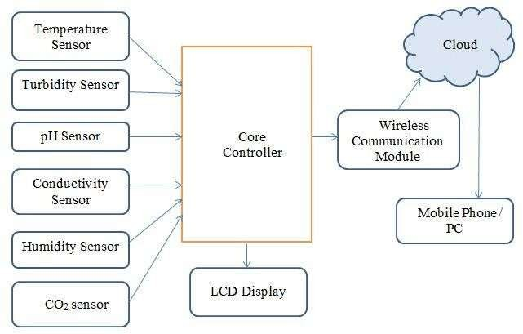**SYSTEM ARCHITECTURE AND DESIGN**

**Fig 3.1 System Architecture Diagram**

The Fig 3.1 explains the proposed water quality monitoring system aims to provide comprehensive and real-time data on key parameters such as temperature, pH, turbidity, and dissolved oxygen in water bodies. This system integrates various sensors, including temperature, pH, turbidity, and dissolved oxygen sensors, with the Arduino ESP32 microcontroller serving as the core controller. By continuously monitoring these parameters, the system offers valuable insights into water quality, enabling informed decision-making for environmental management and conservation efforts.

**3.1 Components**

**1. Temperature Sensor:** This sensor measures the temperature of the water, providing crucial information about thermal variations that can impact aquatic ecosystems and water quality.

**2. pH Sensor:** The pH sensor determines the acidity or alkalinity of the water, which is vital for assessing its suitability for various uses and supporting aquatic life.

**3. Turbidity Sensor:** Measuring the cloudiness or clarity of the water caused by suspended particles, the turbidity sensor indicates overall water cleanliness and potential for sedimentation.

**4. Dissolved Oxygen Sensor:** This sensor measures the concentration of oxygen dissolved in water, essential for supporting aquatic organisms' respiration.

**5. Arduino ESP32 Microcontroller:** Serving as the central processing unit, the ESP32 microcontroller interfaces with the sensors, collects data, and facilitates data transmission to a remote server or display unit.

**3.2 System Architecture**

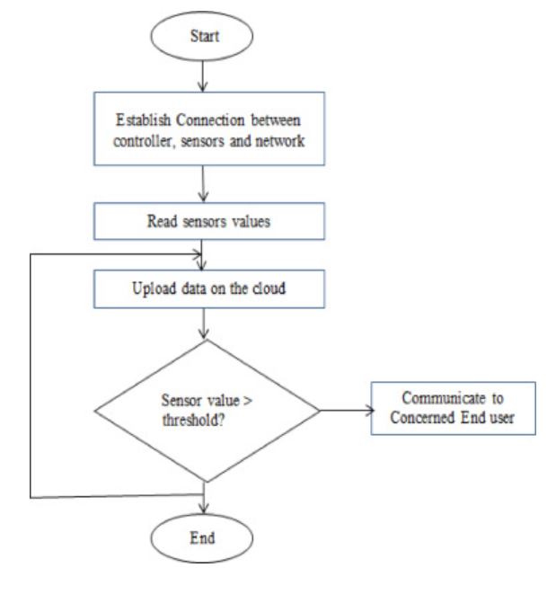 **Fig 3.2 System Architecture Flowchart**

The Fig 3.2 explains the following points present in the flowchart:

**Sensor Interface:** The sensors are connected to the Arduino ESP32 microcontroller through analog or digital interfaces, allowing for data acquisition and processing.

**Data Acquisition:** The microcontroller reads sensor data at predefined intervals and processes it using onboard algorithms to ensure accuracy and reliability.

**Data Transmission:** Processed data is transmitted wirelessly via Wi-Fi or Bluetooth capabilities of the ESP32 to a remote server or display unit for real-time visualization and analysis.

**Power Management:** The system can be powered using a combination of batteries, solar panels, or external power sources, ensuring continuous operation even in remote or off-grid locations.

**3.3 Design Consideration**

**Sensor Calibration:** Regular calibration of sensors is essential to maintain accurate and reliable measurements, ensuring data integrity and consistency.

**Data Logging:** The system should include provisions for logging sensor data locally in case of network connectivity issues, ensuring data continuity and integrity.

**User Interface:** A user-friendly interface, such as a web-based dashboard or mobile application, should be provided for easy access to real-time monitoring data and historical trends.

**Security:** Robust security measures, including encryption and authentication protocols, should be implemented to protect sensitive data transmitted over the network.

**Scalability:** The system should be designed to accommodate future expansion and integration with additional sensors or functionalities to meet evolving monitoring requirements and scale up as needed.

By integrating sensors, microcontrollers, and wireless communication technologies, the proposed water quality monitoring system offers a comprehensive, scalable, and cost-effective solution for monitoring and managing water resources effectively, contributing to environmental sustainability and conservation effort.

**CHAPTER 4**

**METHODOLOGY**

Creating a water quality monitoring system using artificial intelligence (AI), Internet of Things (IoT), Arduino, and sensors involves several steps. Below is a detailed methodology:

**1. Define Requirements and Objectives:**

- Determine the parameters to be monitored such as pH levels, temperature, dissolved oxygen, turbidity, and specific contaminants.

- Establish the monitoring frequency and data transmission requirements.

- Set objectives for the system, such as early detection of water quality issues and real-time data visualization.

**2. Select Sensors:**

- Choose appropriate sensors for each parameter to be monitored.

- Consider factors such as accuracy, reliability, compatibility with Arduino, and cost- effectiveness.

- Common sensors include pH sensors, temperature sensors, dissolved oxygen sensors, turbidity sensors, and water quality sensors for specific contaminants.

**3. Design Hardware Architecture:**

- Design the hardware architecture using Arduino as the microcontroller platform.

- Connect the selected sensors to the Arduino board.

- Incorporate additional components such as power supply, communication modules (e.g., Wi- Fi, GSM), and data storage (e.g., SD card module).

**4. Develop Firmware:**

- Write firmware code for Arduino to interface with the sensors and collect data.

- Implement sensor calibration routines if necessary.

- Program the Arduino to transmit sensor data to a central database or cloud platform using IoT protocols such as MQTT or HTTP.

**Fig 4.1 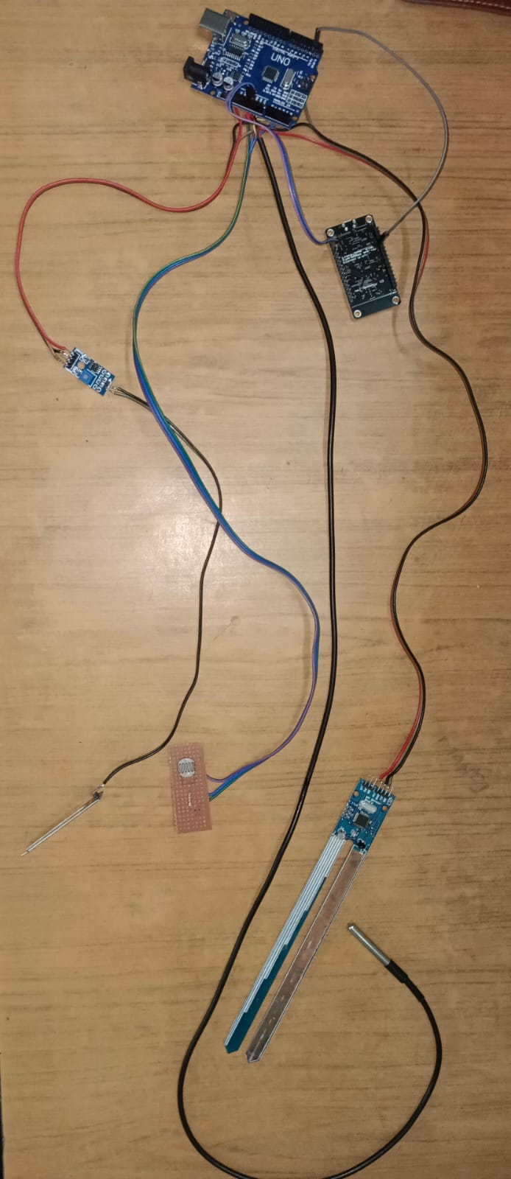Hardware Prototype**

The Fig 4.1 shows the hardware components used in water quality monitoring system. The components used are temperature sensor, pH sensor, turbidity sensor, conductivity sensor, Arduino uno and ESP32 microcontroller. All the components are connected through male to male wires.

**CHAPTER 5**

**CODING AND TESTING**

**SAMPLE CODE**

col=['Temperature**\n**?C (Min)', 'Temperature**\n**?C (Max)',

'Dissolved Oxygen (mg/L) (Min)', 'Dissolved Oxyg en (mg/L) (Max)',

'pH (Min)', 'pH (Max)', 'Conductivity (?mhos/cm) (Min)',

'Conductivity (?mhos/cm) (Max)', 'BOD (mg/L) (Min)', 'BOD (mg/L) (Max)',

'Nitrate N + Nitrite N(mg/L) (Min)',

'Nitrate N + Nitrite N(mg/L) (Max)', 'Fecal Coliform (MPN/100ml) (Min)',

'Fecal Coliform (MPN/100ml) (Max)', 'Total Coliform (MPN/100ml) (Min)',

'Total Coliform (MPN/100ml) (Max)']

fig = plt.figure(figsize=(15,10))

for i **in** range(len(col)):

plt.subplot(4,4,i+1)

plt.title(col[i])

sns.distplot(df,x=df[col[i]])

plt.tight_layout()

plt.show()

*#this one is distplot by features*

fig = plt.figure(figsize=(15,10))

for i **in** range(len(col)):

plt.subplot(4,4,i+1)

plt.title(col[i])

sns.boxplot(data=df,y=df[col[i]],x=df['Type Water Body'])

plt.tight_layout()

plt.show()

*#this one is boxplot by features*

import pandas as pd

import seaborn as sns

*# Assuming 'df' is your DataFrame*

*# Select only numeric columns*

numeric_df = df.select_dtypes(include=['float64', 'int64'])

*# Calculate correlation matrix*

corr_matrix = numeric_df.corr()

*# Plot heatmap*

sns.heatmap(corr_matrix, annot=True, cbar=False, cmap='Blues', fmt='.1f');

import seaborn as sns

*# Assuming 'df' is your DataFrame*

*# Remove rows with missing values in specified columns*

cols = ['Temperature**\n**?C (Max)', 'Dissolved Oxygen (mg/L) (Max)', 'Type Water Body']

cleaned_df = df.dropna(subset=cols)

*# Convert necessary columns to numeric*

cleaned_df['Temperature**\n**?C (Max)'] = pd.to_numeric(cleaned_df['Temperature**\n**?C (Max)'], errors='coerce')

cleaned_df['Dissolved Oxygen (mg/L) (Max)'] = pd.to_numeric(cleaned_df['Dissolved Oxygen (mg/L) (Max)'], errors='coerce')

*# Plot lmplot*

sns.lmplot(data=cleaned_df, x='Temperature**\n**?C (Max)', y='Dissolved Oxygen (mg/L) (Max)', hue='Type Water Body');

import seaborn as sns

*# Assuming 'df' is your DataFrame*

*# Remove rows with missing values in specified columns*

cols = ['Temperature**\n**?C (Min)', 'Dissolved Oxygen (mg/L) (Max)', 'Type Water Body']

cleaned_df = df.dropna(subset=cols)

*# Convert necessary columns to numeric*

cleaned_df['Temperature**\n**?C (Min)'] = pd.to_numeric(cleaned_df['Temperature**\n**?C (Min)'], errors='coerce')

cleaned_df['Dissolved Oxygen (mg/L) (Max)'] = pd.to_numeric(cleaned_df['Dissolved Oxygen (mg/L) (Max)'], errors='coerce')

*# Plot lmplot*

sns.lmplot(data=cleaned_df, x='Temperature**\n**?C (Min)', y='Dissolved Oxygen (mg/L) (Max)', hue='Type Water Body');

import seaborn as sns

*# Assuming 'df' is your DataFrame*

*# Remove rows with missing values in specified columns*

cols = ['Temperature**\n**?C (Max)', 'Dissolved Oxygen (mg/L) (Min)', 'Type Water Body']

cleaned_df = df.dropna(subset=cols)

*# Convert necessary columns to numeric*

cleaned_df['Temperature**\n**?C (Max)'] = pd.to_numeric(cleaned_df['Temperature**\n**?C (Max)'], errors='coerce')

cleaned_df['Dissolved Oxygen (mg/L) (Min)'] = pd.to_numeric(cleaned_df['Dissolved Oxygen (mg/L) (Min)'], errors='coerce')

*# Plot lmplot*

sns.lmplot(data=cleaned_df, x='Temperature**\n**?C (Max)', y='Dissolved Oxygen (mg/L) (Min)', hue='Type Water Body');

import seaborn as sns

import pandas as pd

*# Assuming 'df' is your DataFrame*

*# Remove rows with missing values in specified columns*

cols = ['Temperature**\n**?C (Min)', 'Dissolved Oxygen (mg/L) (Min)', 'Type Water Body']

cleaned_df = df.dropna(subset=cols)

*# Convert necessary columns to numeric*

cleaned_df['Temperature**\n**?C (Min)'] = pd.to_numeric(cleaned_df['Temperature**\n**?C (Min)'], errors='coerce')

cleaned_df['Dissolved Oxygen (mg/L) (Min)'] = pd.to_numeric(cleaned_df['Dissolved Oxygen (mg/L) (Min)'], errors='coerce')

*# Plot lmplot*

sns.lmplot(data=cleaned_df, x='Temperature**\n**?C (Min)', y='Dissolved Oxygen (mg/L) (Min)', hue='Type Water Body');

import seaborn as sns

import pandas as pd

*# Assuming 'df' is your DataFrame*

*# Remove rows with non-numeric values in specified columns*

cols = ['Conductivity (?mhos/cm) (Max)', 'pH (Max)', 'Type Water Body']

cleaned_df = df.dropna(subset=cols)

*# Convert necessary columns to numeric*

cleaned_df['Conductivity (?mhos/cm) (Max)'] = pd.to_numeric(cleaned_df['Conductivity (?mhos/cm) (Max)'], errors='coerce')

cleaned_df['pH (Max)'] = pd.to_numeric(cleaned_df['pH (Max)'], errors='coerce')

*# Plot lmplot*

sns.lmplot(data=cleaned_df, x='Conductivity (?mhos/cm) (Max)', y='pH (Max)', hue='Type Water Body');

import seaborn as sns

import pandas as pd

*# Assuming 'df' is your DataFrame*

*# Remove rows with non-numeric values in specified columns*

cols = ['Conductivity (?mhos/cm) (Min)', 'pH (Max)', 'Type Water Body']

cleaned_df = df.dropna(subset=cols)

*# Convert necessary columns to numeric*

cleaned_df['Conductivity (?mhos/cm) (Min)'] = pd.to_numeric(cleaned_df['Conductivity (?mhos/cm) (Min)'], errors='coerce')

cleaned_df['pH (Max)'] = pd.to_numeric(cleaned_df['pH (Max)'], errors='coerce')

*# Plot lmplot*

sns.lmplot(data=cleaned_df, x='Conductivity (?mhos/cm) (Min)', y='pH (Max)', hue='Type Water Body');

import seaborn as sns

import pandas as pd

*# Assuming 'df' is your DataFrame*

*# Remove rows with non-numeric values in specified columns*

cols = ['Conductivity (?mhos/cm) (Max)', 'pH (Min)', 'Type Water Body']

cleaned_df = df.dropna(subset=cols)

*# Convert necessary columns to numeric*

cleaned_df['Conductivity (?mhos/cm) (Max)'] = pd.to_numeric(cleaned_df['Conductivity (?mhos/cm) (Max)'], errors='coerce')

cleaned_df['pH (Min)'] = pd.to_numeric(cleaned_df['pH (Min)'], errors='coerce')

*# Plot lmplot*

sns.lmplot(data=cleaned_df, x='Conductivity (?mhos/cm) (Max)', y='pH (Min)', hue='Type Water Body');

import seaborn as sns

import pandas as pd

*# Assuming 'df' is your DataFrame*

*# Remove rows with non-numeric values in specified columns*

cols = ['Conductivity (?mhos/cm) (Min)', 'pH (Min)', 'Type Water Body']

cleaned_df = df.dropna(subset=cols)

*# Convert necessary columns to numeric*

cleaned_df['Conductivity (?mhos/cm) (Min)'] = pd.to_numeric(cleaned_df['Conductivity (?mhos/cm) (Min)'], errors='coerce')

cleaned_df['pH (Min)'] = pd.to_numeric(cleaned_df['pH (Min)'], errors='coerce')

*# Plot lmplot*

sns.lmplot(data=cleaned_df, x='Conductivity (?mhos/cm) (Min)', y='pH (Min)', hue='Type Water Body');

from IPython.display import Image

import category_encoders as ce

import graphviz

import lingam

from lingam.utils import make_dot, make_prior_knowledge

df1 = df.drop(["STN**\n**Code","Name of Monitoring Location"], axis=1)

df1 = df1.dropna(how='any')

display(pd.DataFrame(df1.isnull().sum()).T)

df_list = df1.columns.to_list()

df_dict = {}

for i, column **in** zip(range(len(df_list)), df_list):

df_dict[column] = i

print(len(df_list))

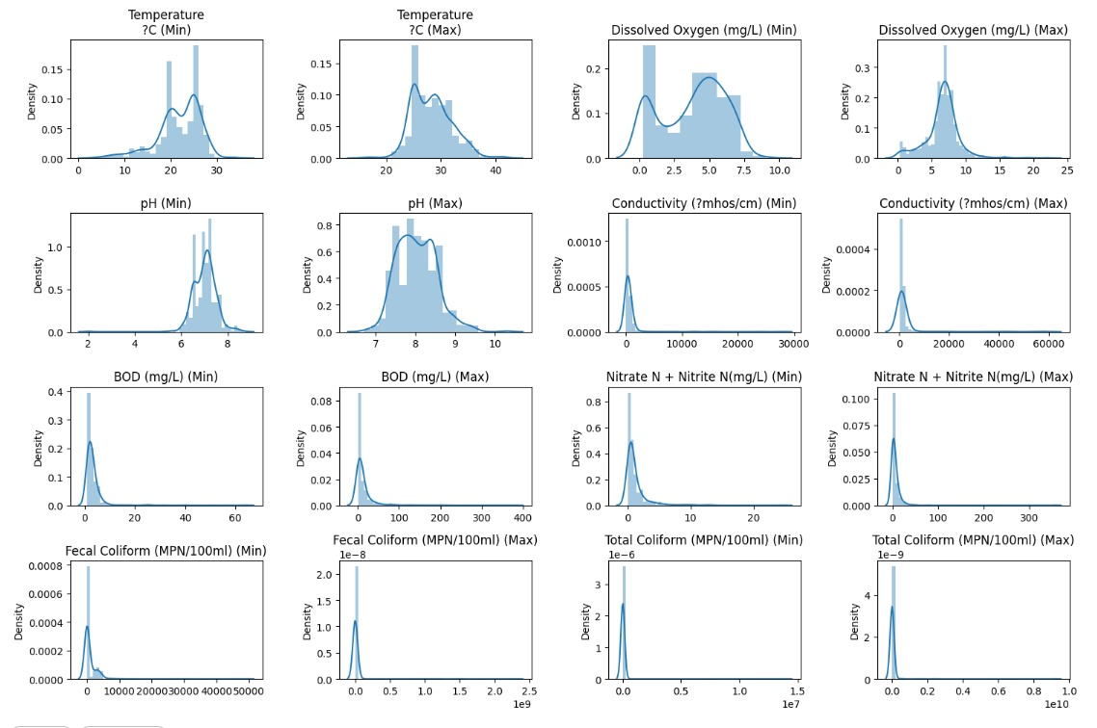

**Fig 5.1 Pre-Processing Data Graph**

The Fig 5.1 explains that pre-processing the data involves several steps to ensure its quality and suitability for analysis. Firstly, missing or erroneous values are identified and either filled in or removed. Next, outliers are detected and handled appropriately, often by applying statistical techniques or domain-specific knowledge. Data normalization or standardization may then be performed to bring all variables to a similar scale, preventing biases in the analysis.

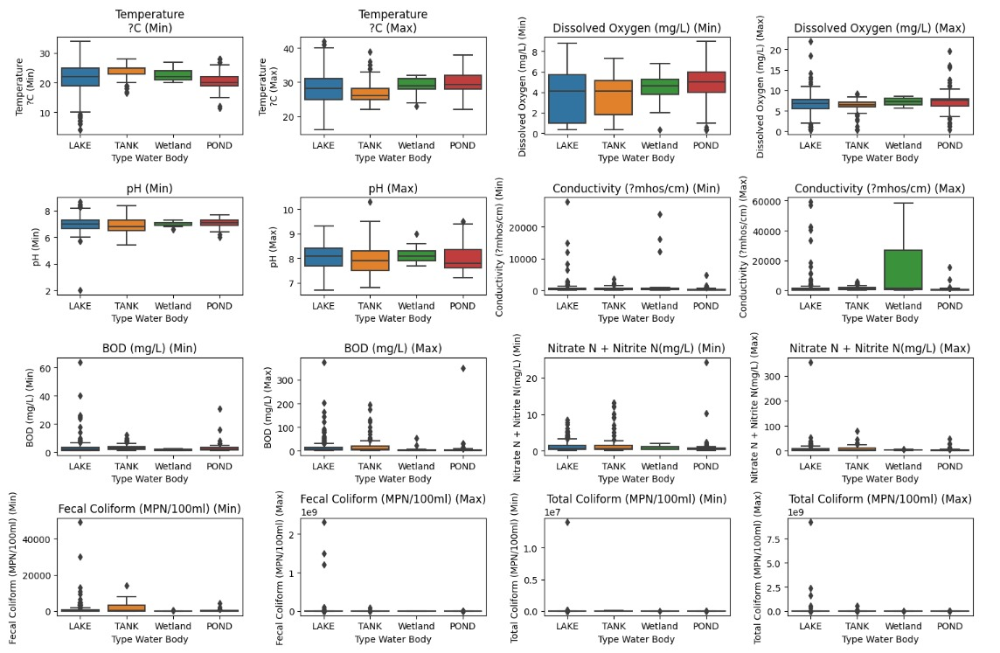

**Fig 5.2 Box Plot**

The Fig 5.2 explains that box plots are invaluable in water quality monitoring systems for visualizing key statistical parameters such as median, quartiles, and outliers. They provide a concise summary of the distribution of water quality data, aiding in the identification of trends, variations, and anomalies. By displaying the central tendency, spread, and skewness of water quality parameters, box plots enable quick insights into the overall condition of water bodies, facilitating informed decision-making for environmental management and resource allocation.

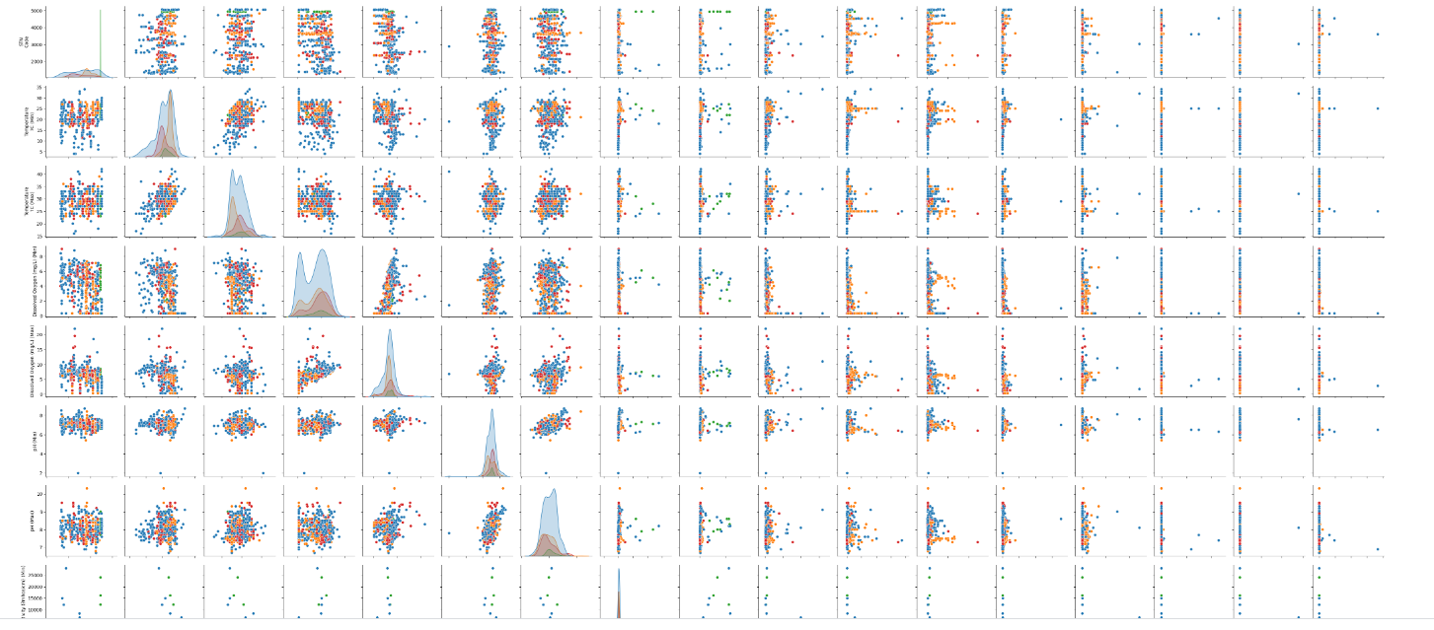

**Fig 5.3 Pairplot**

The Fig 5.3 explains that pairplots, commonly used in data analysis, display pairwise relationships between variables in a dataset. Each pair of variables is represented by a scatterplot, histogram, or other visualizations, revealing correlations, distributions, and trends. They offer a comprehensive overview of the data's multivariate structure, aiding in exploration and understanding of complex relationships.

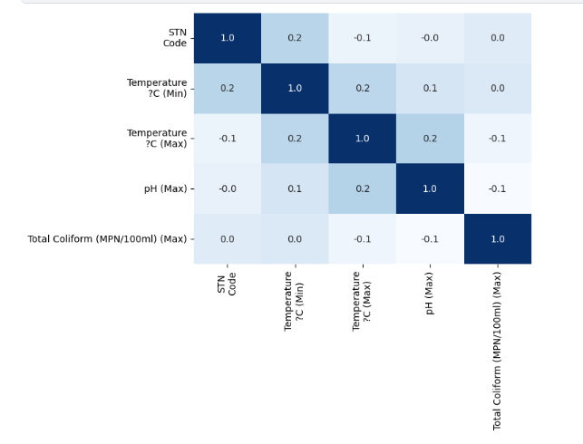

**Fig 5.4 Heatmaps**

The Fig 5.4 explains that heatmaps are graphical representations of data where values in a matrix are depicted as colors. Typically, rows and columns represent variables, and the color intensity indicates the magnitude of values. They provide a visual summary of relationships and patterns in large datasets, aiding in identifying clusters, trends, and correlations efficiently.

**CHAPTER 6**

**RESULTS**

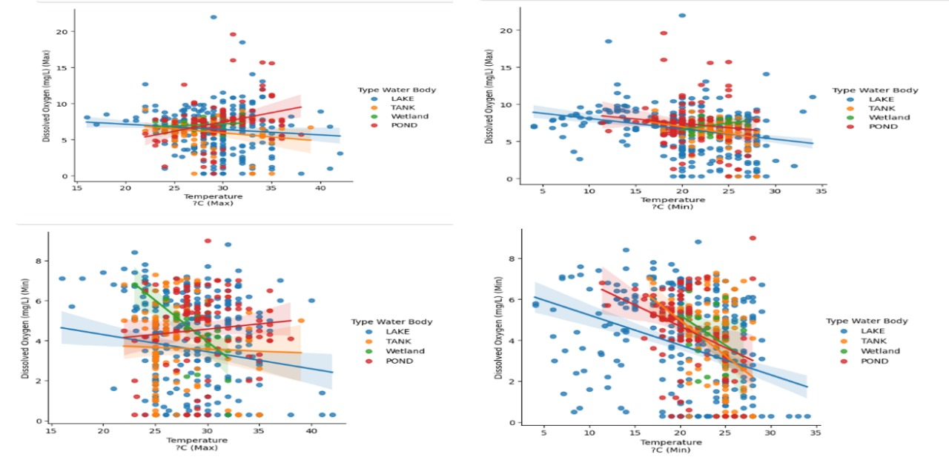

**Fig 6.1 Plot Comparision O2 And Temperature**

The Fig 6.1 explains that the plot compares dissolved oxygen levels and temperature over time, showcasing fluctuations in both parameters. It distinguishes between actual data points from the dataset and predicted values generated by the model, providing insight into the relationship between dissolved oxygen concentration and temperature variations.

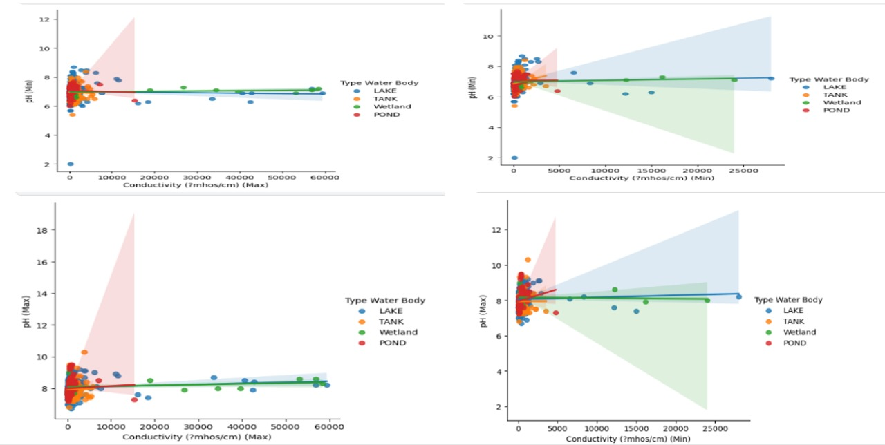

**Fig 6.2 Comparision For Ph And Conductivity**

The Fig 6.2 explains that the plot visually contrasts pH and conductivity values extracted from the dataset, offering insights into their relationship. By displaying fluctuations and trends over time or across different sampling locations, it elucidates any correlations or patterns between these key parameters, aiding in water quality assessment and monitoring efforts.

**CHAPTER 7**

**CONCLUSION AND FUTURE ENHANCEMENT**

Water contamination poses a significant threat to global health, economies, and biodiversity, making it imperative to understand its causes, impacts, and methods of monitoring water quality. This research delves into these aspects, aiming to shed light on the multifaceted nature of water quality management. Water contamination can arise from various sources, including industrial discharge, agricultural runoff, sewage overflow, and improper waste disposal. These pollutants can have far-reaching consequences, jeopardizing human health, disrupting ecosystems, and impacting economic activities such as agriculture, fisheries, and tourism.

Effective water quality monitoring is crucial for identifying contamination sources, assessing risks, and implementing timely interventions. Traditional monitoring methods often involve periodic sampling and laboratory analysis, which can be time-consuming, labor-intensive, and costly. To address these challenges, researchers are exploring innovative approaches, including the use of Internet of Things (IoT) technology for real-time monitoring and data analysis. IoT-based strategies offer several advantages, including scalability, remote accessibility, and the ability to integrate diverse sensor networks for comprehensive monitoring of water quality parameters.

While several smart monitoring systems already exist, ongoing research aims to enhance their efficiency, reliability, and accessibility. By leveraging advancements in sensor technology, data analytics, and communication protocols, researchers are developing IoT-based solutions that provide continuous monitoring and quick notifications to relevant authorities in the event of water quality deviations or contamination incidents. These systems utilize a combination of physical sensors, such as those measuring temperature, pH, dissolved oxygen, and turbidity, along with chemical sensors capable of detecting specific pollutants or contaminants of concern.

The methodology developed in this research is designed to be both cost-effective and user-friendly, ensuring widespread adoption and implementation. By utilizing off-the-shelf hardware components, open-source software platforms, and cloud-based data storage and analytics, the proposed system minimizes infrastructure costs while maximizing flexibility and scalability. Furthermore, the user interface is designed to be intuitive and accessible, allowing non-experts to easily navigate and interpret the monitoring data.

One of the key advantages of IoT-based water quality monitoring systems is their ability to provide real-time insights and actionable information to decision-makers and stakeholders. By continuously monitoring water quality parameters and transmitting data to centralized platforms, these systems enable authorities to detect contamination events early, initiate response measures promptly, and mitigate potential risks to public health and the environment. Moreover, by leveraging machine learning algorithms and predictive analytics, these systems can forecast water quality trends, identify emerging threats, and optimize resource allocation for monitoring and management efforts.

Looking ahead, future developments in IoT-based water quality monitoring may include the use of enhanced sensors with greater accuracy, sensitivity, and durability. Additionally, the adoption of standardized wireless communication protocols and IoT integration standards will facilitate interoperability and data exchange between different monitoring systems and stakeholders.

**REFERENCES**

[1] S. Pasika, S.T. Gandla.Smart water quality monitoring system with cost effective using IoT

[2]M. Mukta, S. Islam, S.D. Barman, A.W. Reza, M.S. Hossain Khan "Iot based smart water quality monitoring system.

[3]S. Konde, S. Deosarkar ,IOT based water quality monitoring system Proceedings of the 2nd International Conference on Communication & Information Processing (ICCIP) (2020)

[4]M.K. Amruta, M.T. Satish ,Solar powered water quality monitoring system using wireless sensor network, Proceedings of the International Mutli-Conference on Automation, Computing, Communication, Control and Compressed Sensing (iMac4s) (2013).

[5]T. Sugapriyaa, S. Rakshaya, K. Ramyadevi, M. Ramya, P.G. Rashmi, Smart water quality monitoring system for real time applications Int. J. Pure Appl. Math., 118 (2018), pp. 1363-1369.

[6]K.A. Unnikrishna Menon, D. P., M.V. Ramesh,Wireless sensor network for river water quality monitoring in India,Proceedings of the Third International Conference on Computing, Communication and Networking Technologies (ICCCNT'12) (2012).

[7]A.N. Prasad, K.A. Mamun, F.R. Islam, H. Haqva ,Smart water quality monitoring system ,Proceedings of the 2nd Asia-Pacific World Congress on Computer Science and Engineering (APWC on CSE) (2015).

[8]A. Jerom B., R. Manimegalai, R. Manimegalai,An IoT based smart water quality monitoring system using cloud, Proceedings of the International Conference on Emerging Trends in Information Technology and Engineering (ic-ETITE) (2020)

[9]S. Geetha, S. Gouthami, Internet of things enabled real time water quality monitoring system, Smart Water, 2 (1) (2016)

[10]B. Sengupta, S. Sawant, M. Dhanawade, S. Bhosale,Water quality monitoring using IoT, Int. Res. J. Eng. Technol., 6 (2019)

[11] M.J.V. Kumar, K. Samalla,Design and Development of water quality monitoring system in IoT Int. J. Recent Technol. Eng. (IJRTE), Volume-7 (Issue-5S3) (2019), pp. 2277-3878,ISSNFebruary 2019.

[12] A.T. Demetillo, M.V. Japitana, E.B. Taboada,A system for monitoring water quality in a large aquatic area using wireless sensor network technology,Sustain. Environ. Res., 29 (2019).

[13] B. Anuradha, R. Chaitra, D. Pooja,IoT based low cost system for monitoring of water quality in real time,Int. Res. J. Eng. Technol. (IRJET), Volume: 05 (Issue: 05) (2018),May-2018.

[14]S.N. Shivappriya, M. Priyadarsini, A. Stateczny, C. Puttamadappa, B.D. Parameshachari, Cascade object detection and remote sensing object detection method based on trainable activation function,Remote Sens., 13 (2) (2021).

[15] S.N. Shivappriya, S. Karthikeyan, S. Prabu, R. Pérez de Prado, B.D. Parameshachari, A modified ABC-SQP-based combined approach for the optimization of a parallel hybrid electric vehicle,Energies, 13 (17) (2020)

[16]S.A. Hamid, A.M.A. Rahim, S.Y. Fadhlullah, S. Abdullah, Z. Muhammad, N.A.M. Leh,IoT based water quality monitoring system and evaluation,Proceedings of the 10th IEEE International Conference on Control System, Computing and Engineering (ICCSCE) (2020).

[17] C. Puttamadappa

,B.D. Parameshachari,Demand side management of small scale loads in a smart grid using glow-worm swarm optimization technique,Microprocess. Microsyst., 71 (2019).

[18]T.N. Nguyen, B.H. Liu, S.I. Chu, D.T. Do, T.D. Nguyen,WRSNs: toward an efficient scheduling for mobile chargers, IEEE Sens. J., 20 (12) (2020)

[19] S. Gupta, M. Kohli, R. Kumar, S. Bandral,IoT based underwater robot for water quality monitoring,IOP Conf. Ser. Mater. Sci. Eng., 1033 2021)

[20]P.N. Hiremath, J. Armentrout, S. Vu, T.N. Nguyen, Q.T. Minh, P.H. Phung,MyWebGuard: toward a user-oriented tool for security and privacy protection on the web,Proceedings of the International Conference on Future Data and Security Engineering, Springer (2019).